**System Ready for Development Environment**

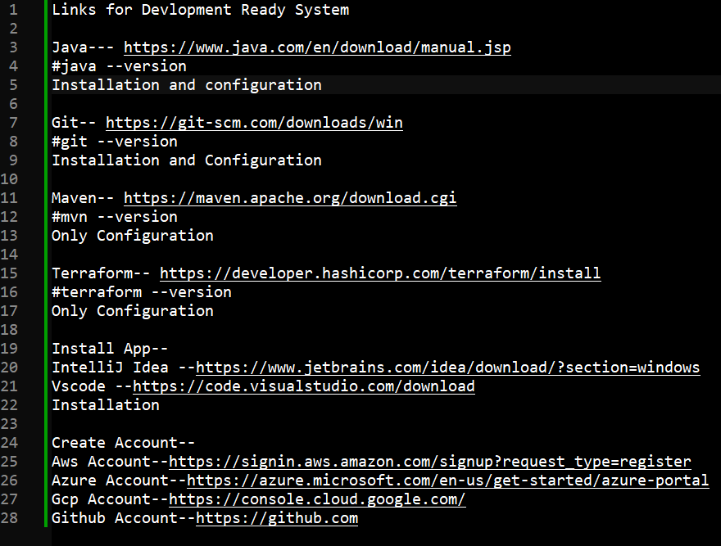

Links for Devlopment Ready System

Java--- https://www.java.com/en/download/manual.jsp

#java --version

Installation and configuration

Git-- https://git-scm.com/downloads/win

#git --version

Installation and Configuration

Maven-- https://maven.apache.org/download.cgi

#mvn --version

Only Configuration

Terraform-- https://developer.hashicorp.com/terraform/install

#terraform --version

Only Configuration

Install App--

IntelliJ Idea --https://www.jetbrains.com/idea/download/?section=windows

Vscode --https://code.visualstudio.com/download

Installation

Create Account--

Aws Account--https://signin.aws.amazon.com/signup?request_type=register

Azure Account--https://azure.microsoft.com/en-us/get-started/azure-portal

Gcp Account--https://console.cloud.google.com/

Github Account--https://github.com

